**Tuần 9 – 10**

**Tạo class CartItem**

public int iMaSach { get; set; }

public string sTenSach { get; set; }

public string sAnhBia { get; set; }

public double dDonGia { get; set; }

public int iSoLuong { get; set; }

public double ThanhTien { get { return iSoLuong * dDonGia; } }

DataClasses1DataContext data = new DataClasses1DataContext();

public CartItem(int MaSach)

{

tbl_SanPham sach = data.tbl_SanPhams.SingleOrDefault(n => n.MaSanPham == MaSach);

if (sach != null)

{

iMaSach = MaSach;

sTenSach = sach.TenSP;

sAnhBia = sach.HinhAnh;

dDonGia = double.Parse(sach.DonGia.ToString());

iSoLuong = 1;

}

}

**Tạo class GioHang**

public List<CartItem> dsSach;

public GioHang()

{

dsSach = new List<CartItem>();

}

public GioHang(List<CartItem> lst)

{

dsSach = lst;

}

public int Somathang()

{

if (dsSach == null)

return 0;

return dsSach.Count();

}

public int TongSoLuong()

{

if (dsSach == null)

return 0;

return dsSach.Sum(t=>t.iSoLuong);

}

public double TongThanhTien()

{

if (dsSach == null)

return 0;

return dsSach.Sum(t => t.ThanhTien);

}

public int Them(int ms)

{

CartItem a = dsSach.Find(i=>i.iMaSach == ms);

if (a == null)

{

CartItem sach = new CartItem(ms);

if (sach == null)

return -1;

dsSach.Add(sach);

}

else

a.iSoLuong++;

return 1;

}

**Tạo layout_KhachHang để thiết kế trang chính**



<body>

<div class="container-fluid">

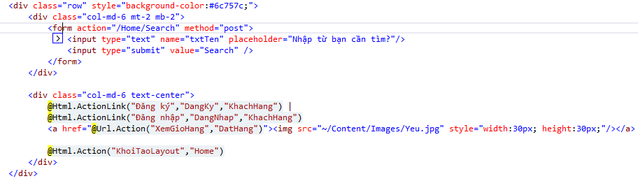

<div class="row mb-4 mr-3" style="background-color:#32363e; color:#1f57c1;">

<div class="col-md-5"></div>

<div class="col-md-7">

<ul class="nav navbar">

<li class="nav-item"><a class="nav-link" href="/Home/Index">Trang chủ</a></li>

<li class="nav-item"><a class="nav-link" href="#">Giới thiệu</a></li>

<li class="nav-item"><a class="nav-link" href="#P">Hướng dẫn sử dụng</a></li>

<li class="nav-item"><a class="nav-link" href="#">Liên hệ</a></li>

</ul>

</div>

</div>

<div class="row">

@RenderBody()

</div>

</div>

</body>

**Khi nhấn vào chọn mua sẽ xuất hiện số mặt hàng mà mình đã chọn**



public ActionResult KhoiTaoLayout() **nằm trong controller Home**

{

GioHang gio = (GioHang)Session["gh"];

tbl_KhachHang Khach = Session["kh"] as tbl_KhachHang;

ViewBag.kh = Khach;

return PartialView(gio);

}

**Goto View KhoiTaoLayout**

@using _12_NguyenAnhThu_2001180005_CNWeb9.Models;

@model GioHang

@if (Model == null)

{

<label>(0)</label>

}

else

{

<label>(@Model.Somathang())</label>

}

@if (ViewBag.kh != null)

{

tbl_KhachHang k = ViewBag.kh;

<p>Xin chào, @k.TenKH

<a href="/KhacHang/LogOut"><img src="~/Content/Images/logout.png" style="width:30px; height:30px;"></a>

</p>

}

**Tạo trang Index hiển thị sách nằm trong controller Home**

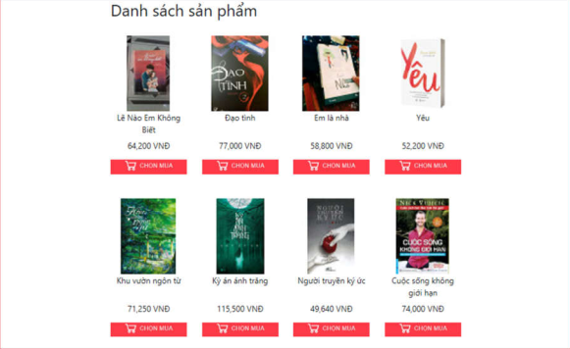

public ActionResult Index()

{

List<tbl_SanPham> dsSP = data.tbl_SanPhams.Where(s => s.SoLuongTon > 0).ToList();

return View(dsSP);

}

**Goto View Index**

@using _12_NguyenAnhThu_2001180005_CNWeb9.Models;

@{

ViewBag.Title = "Index";

Layout = "~/Views/Shared/_LayoutKhachHang.cshtml";

}

@model List<tbl_SanPham>

<h2 class="text-center">Danh sách sản phẩm</h2>

<div class="container">

<div class="row">

@foreach (tbl_SanPham sp in Model)

{

<div class="col-md-3 text-center mt-4 mb-4">

<img src="~/Content/Images/@sp.HinhAnh" class="w-100"/>

<p style="height:40px;">@sp.TenSP</p>

<p>@String.Format("{0:#,###}",@sp.DonGia) VNĐ</p>

<a href="@Url.Action("ThemMatHang", "DatHang", new { msp = sp.MaSanPham})"><img src="~/Content/Images/ChonMua.jpg" /></a>

</div>

}

</div>

</div>

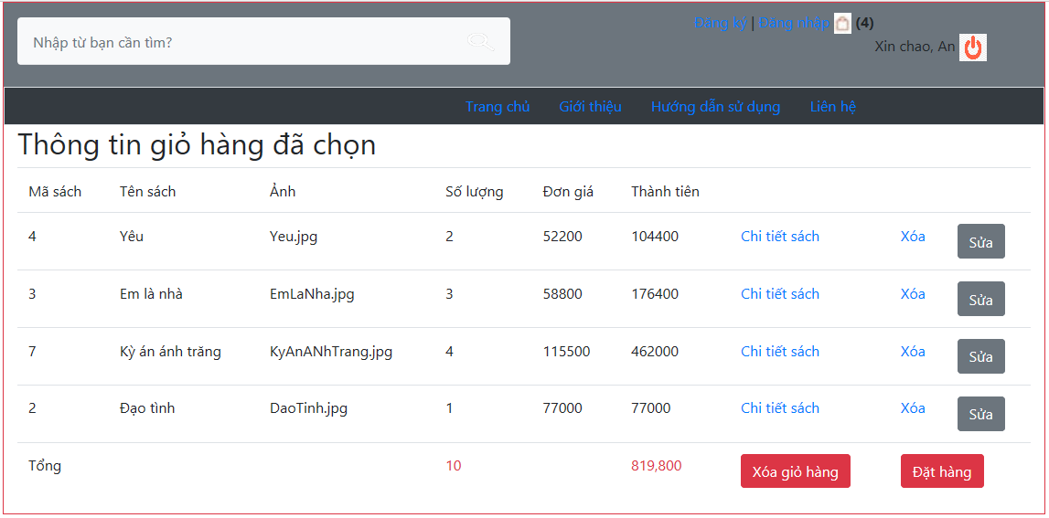

**Khi muốn chọn mua và xem giỏ hàng phải tạo controller DatHang**

public ActionResult ThemMatHang(int msp)

{

GioHang gh = (GioHang)Session["gh"];

if (gh == null)

gh = new GioHang();

int kq = gh.Them(msp);

Session["gh"] = gh;

return RedirectToAction("Index","Home");

}

public ActionResult XemGioHang()

{

GioHang gh = (GioHang)Session["gh"];

return View(gh);

}

**Goto View XemGioHang**

@using _12_NguyenAnhThu_2001180005_CNWeb9.Models;

@{

ViewBag.Title = "XemGioHang";

Layout = "~/Views/Shared/_LayoutKhachHang.cshtml";

}

@model GioHang

<h2>Thông tin giỏ hàng đã chọn</h2>

<table class="table">

<tr>

<td>Mã sách</td>

<td>Tên sách</td>

<td>Ảnh</td>

<td>Số lượng</td>

<td>Đơn giá</td>

<td>Thành tiền</td>

<td></td>

<td></td>

<td></td>

</tr>

@foreach (CartItem item in Model.dsSach)

{

<tr>

<td>@item.iMaSach</td>

<td>@item.sTenSach</td>

<td>@item.sAnhBia</td>

<td>@item.iSoLuong</td>

<td>@item.dDonGia</td>

<td>@item.ThanhTien</td>

<td><a href="#">Chi tiết sách</a></td>

<td><a href="#">Xóa</a></td>

<td><a href="#" class="btn btn-secondary">Sửa</a></td>

</tr>

}

<tr>

<td colspan="3">Tổng</td>

<td class="text-danger text-bold">@Model.TongSoLuong()</td>

<td></td>

<td class="text-danger text-bold">@String.Format("{0:#,##}", Model.TongThanhTien())</td>

<td colspan="2">@Html.ActionLink("Xóa giỏ hàng", "XoaGioHang", "DatHang", new { @class = "btn btn-danger"})</td>

<td colspan="2">@Html.ActionLink("Đặt hàng", "XacNhanDonHang", "DatHang", new { @class = "btn btn-danger"})</td>

</tr>

</table>

**Sau khi đăng nhập thành công mới dc đặt hang**



**Tạo trang đăng nhập nằm trong trang controller KhachHang**

DataClasses1DataContext data = new DataClasses1DataContext();

[HttpGet]

public ActionResult DangNhap()

{

return View();

}

[HttpPost]

public ActionResult DangNhap(FormCollection col)

{

string ten = col["txtName"];

string mk = col["txtPass"];

tbl_KhachHang kh = data.tbl_KhachHangs.FirstOrDefault(k => k.TenKH == ten && k.MatKhau == mk);

if (kh != null)

{

Session["kh"] = kh;

return RedirectToAction("Index","Home");

}

return View();

}

**Goto View DangNhap**

@{

ViewBag.Title = "DangNhap";

Layout = "~/Views/Shared/_LayoutKhachHang.cshtml";

}

<h2 style="text-align:center">Đăng nhập</h2>

<form action="/KhachHang/DangNhap" method="post">

<div class="row">

<div class="col-md-4"></div>

<div class="col-md-4">

<input type="text" name="txtName" placeholder="Tên khách hàng" class="mb-3"/> <br />

<input type="password" name="txtPass" placeholder="Mật khẩu" class="mb-3"/> <br />

<input type="submit" value="Đăng nhập" />

</div>

<div class="col-md-4"></div>

</div>

</form>

@if (Request.HttpMethod == "POST")

{

if (ViewBag.tb != null)

{

<p>@ViewBag.tb</p>

}

}

**Tạo nút Đặt hàng trong Controller DatHang**

[HttpGet]

public ActionResult XacNhanDonHang()

{

tbl_KhachHang Khach = Session["kh"] as tbl_KhachHang;

if (Khach == null)

return RedirectToAction("DangNhap","KhachHang");

GioHang gio = Session["gh"] as GioHang;

if (gio == null || gio.Somathang() == 0)

return RedirectToAction("XemGioHang","DatHang");

ViewBag.khach = Khach;

return View(gio);

}

[HttpPost]

public ActionResult TaoDonDatHang(FormCollection col)

{

String ngaygiao = col["txtDate"];

DateTime ngayhen = DateTime.Parse(ngaygiao);

tbl_KhachHang kh = (tbl_KhachHang)Session["kh"];

tbl_HoaDon hd = new tbl_HoaDon();

hd.MaKH = kh.MaKhachHang;

hd.NgayHoaDon = DateTime.Now;

hd.NgayGiao = ngayhen;

data.tbl_HoaDons.InsertOnSubmit(hd);

data.SubmitChanges();

GioHang gh = (GioHang)Session["gh"];

foreach (CartItem sp in gh.dsSach)

{

tbl_ChiTiet ct = new tbl_ChiTiet();

ct.MaHD = hd.MaHoaDon;

ct.MaSP = sp.iMaSach;

ct.SoLuong = sp.iSoLuong;

data.tbl_ChiTiets.InsertOnSubmit(ct);

}

data.SubmitChanges();

Session["gh"] = null;

return View();

}

**Goto View XacNhanDonHang**

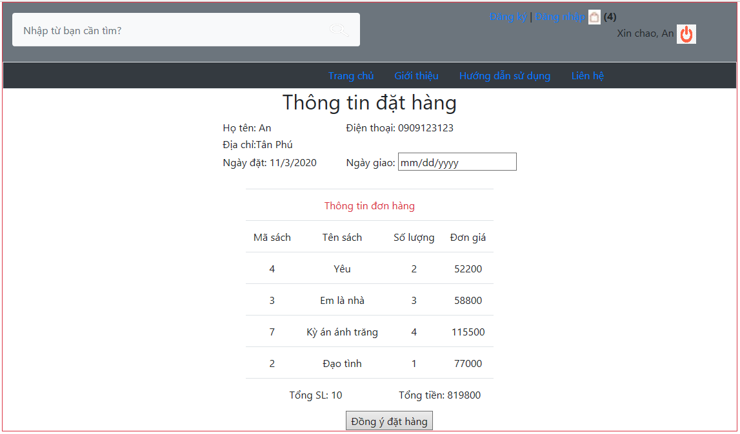

@using _36_NguyenAnhThu_2001180005_CNWeb10.Models;

@{

ViewBag.Title = "XacNhanDonHang";

Layout = "~/Views/Shared/_LayoutKhachHang.cshtml";

tbl_KhachHang khachhang = ViewBag.khach;

}

@model GioHang

<div class="container">

<form action="/DatHang/TaoDonDatHang" method="post">

<h2>Thông tin đặt hàng</h2>

<table style="display:inline" class="text-left">

<tr>

<td>Họ tên: @khachhang.TenKH</td>

<td>Điện thoại: @khachhang.SoDienThoai</td>

</tr>

<tr>

<td colspan="2" class="text-left">Địa chỉ: @khachhang.DiaChi</td>

</tr>

<tr>

<td>Ngày đặt: @DateTime.Now.ToShortDateString()</td>

<td>Ngày giao: <input type="date" name="txtDate"/></td>

</tr>

<tr>

<td>&nbsp;</td>

<td></td>

</tr>

<tr>

<td colspan="2" class="text-center">

<table class="table" style="display:inline">

<tr>

<td colspan="4" class="text-danger">Thông tin đơn đặt</td>

</tr>

<tr>

<td>Mã sách</td>

<td>Tên sách</td>

<td>Số lượng</td>

<td>Đơn giá</td>

</tr>

@foreach (CartItem item in Model.dsSach)

{

<tr>

<td>@item.iMaSach</td>

<td>@item.sTenSach</td>

<td>@item.iSoLuong</td>

<td>@item.dDonGia</td>

</tr>

}

<tr>

<td colspan="2">Tổng số lượng: @Model.TongSoLuong()</td>

<td colspan="2">Tổng tiền: @Model.TongThanhTien()</td>

</tr>

</table>

</td>

</tr>

<tr>

<td></td>

<td><input type="submit" value="Đồng ý đặt hàng"/></td>

</tr>

</table>

</form>

</div>

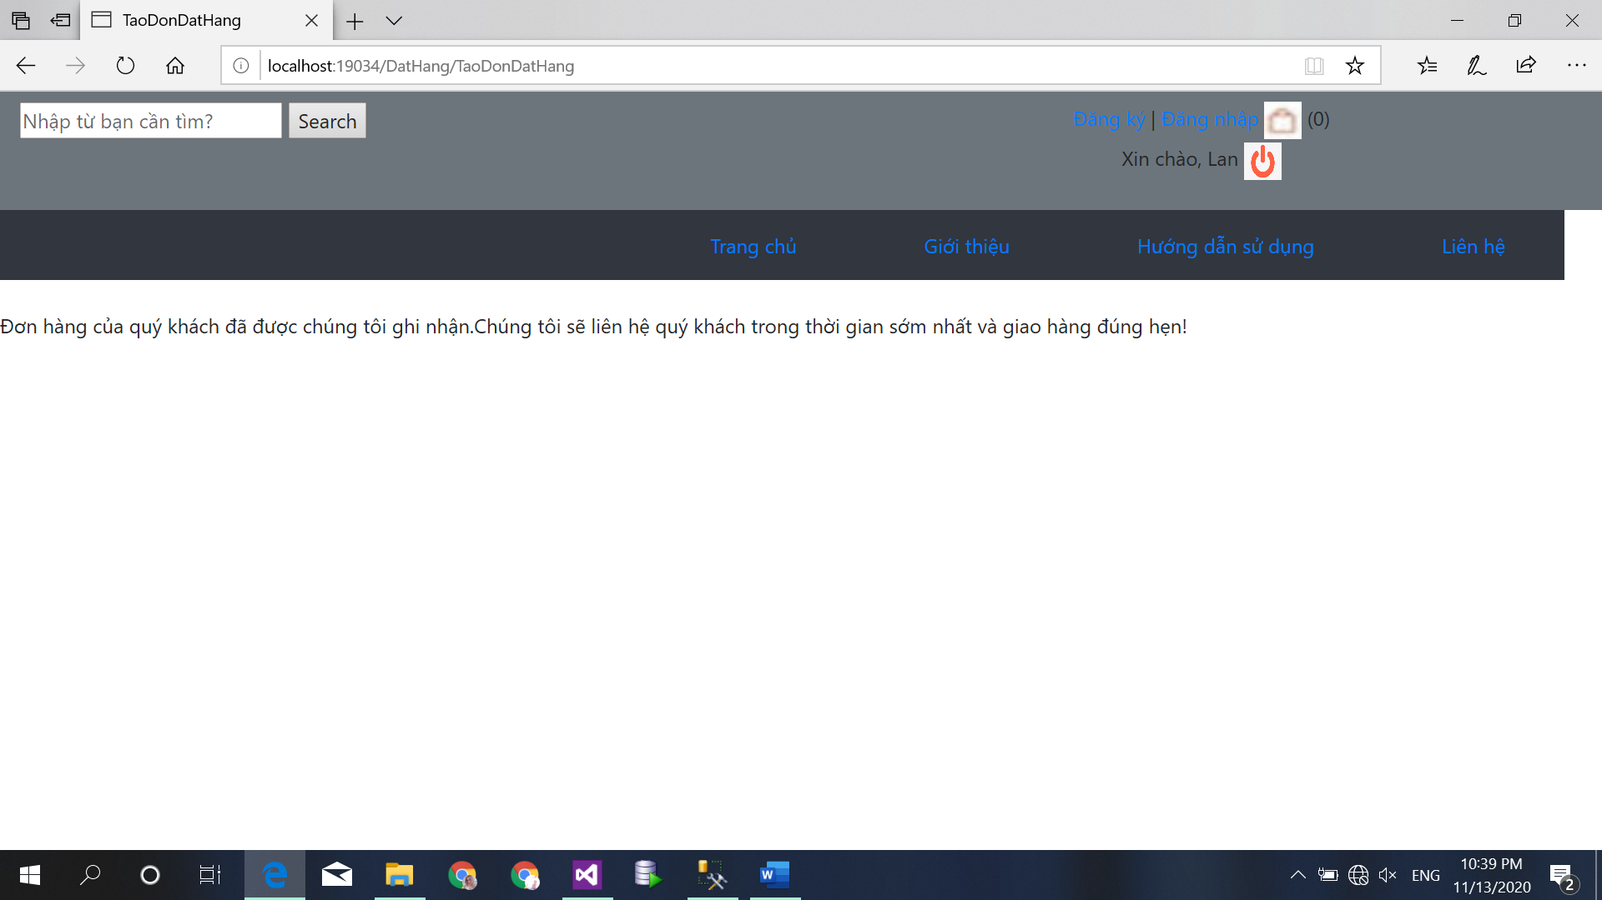

**Goto View TaoDonDatHang**

@using _36_NguyenAnhThu_2001180005_CNWeb10.Models;

@{

ViewBag.Title = "TaoDonDatHang";

Layout = "~/Views/Shared/_LayoutKhachHang.cshtml";

}

<p>Đơn hàng của quý khách đã được chúng tôi ghi nhận.</p> <br />

<p>Chúng tôi sẽ liên hệ quý khách trong thời gian sớm nhất và giao hàng đúng hẹn!</p>

**Tuần 8**

**Tạo layout KhachHang , bên trái thiết kế menu đứng**



<body>

<div class="container-fluid">

<div class="row">

<div class="col-md-4">

<h1>CHỦ ĐỀ</h1>

@Html.Action("DSMenu_ChuDe", "BT1")

<h1>NHÀ XUẤT BẢN</h1>

@Html.Action("DSMenu_NXB", "BT1")

</div>

<div class="col-md-8">

<div >

<img style="width:800px" src="~/Content/HinhAnhSP/asp.net-mvc.jpg" />

</div>

<div>

@RenderBody()

</div>

</div>

</div>

</div>

</body>

**Tạo Index hiển thị 5 cuốn sách**

DataClasses1DataContext data = new DataClasses1DataContext();

public ActionResult Index()

{

List<Sach> dsSach = data.Saches.OrderByDescending(s => s.NgayCapNhat).Take(5).ToList();

ViewBag.tc = "Đây là 5 quyển sách mới cập nhật";

return View(dsSach);

}

**Goto View Index**

@using _36_NguyenAnhThu_2001180005_CNWeb8.Models;

@model List<Sach>

@helper Truncate(string input, int length)

{

if(input.Length < length)

{

@input

}

else

{

@input.Substring(0,length) <text>...</text>

}

}

<h2>Sách mới</h2>

<div class="product-group">

<div class="row">

@foreach (Sach s in @Model)

{

<div class="col-md-3 card mr-2 mt-2 text-center">

<div class="card-product text-center">

<img style="width:300px; height:350px; " class="card-img-top mt-2" src="~/Content/HinhAnhSP/@s.AnhBia" />

</div>

<div class="card-body">

<h5 style="font-size:30px;" class="card-title">@Truncate(s.TenSach,30)</h5>

@Html.ActionLink("Chi tiết", "Details", "BT1", new { id = @s.MaSach }, new { @class = "btn btn-warning"})

@Html.ActionLink("Chọn", "Details", "BT1", new { id = @s.MaSach }, new { @class = "btn btn-warning"})

</div>

</div>

}

</div>

</div>

**Tạo DS menu ChuDe va DS menu NXB (nằm bên trái)**

public ActionResult DSMenu_ChuDe()

{

List<ChuDe> dsCD = data.ChuDes.ToList();

return PartialView(dsCD);

}

public ActionResult DSMenu_NXB()

{

List<NhaXuatBan> dsNXB = data.NhaXuatBans.ToList();

return PartialView(dsNXB);

}

**Goto View DSMenu_ChuDe và DSMenu_NXB**

@using _36_NguyenAnhThu_2001180005_CNWeb8.Models;

@model List<ChuDe>

<ul class="nav flex-column">

@foreach (ChuDe cd in @Model)

{

<li class="nav-item">

@Html.ActionLink(cd.TenChuDe, "HTSachTheoChuDe", "BT1", new { mcd = cd.MaChuDe }, new {@class = "nav-link" })

</li>

}

</ul>

@using _36_NguyenAnhThu_2001180005_CNWeb8.Models;

@model List<NhaXuatBan>

<ul class="nav flex-column">

@foreach (NhaXuatBan nxb in @Model)

{

<li class="nav-item">

@Html.ActionLink(nxb.TenNXB, "HTSachTheoNXB", "BT1", new { mnxb = nxb.MaNXB }, new {@class = "nav-link" })

</li>

}

</ul>

**Khi nhấn vào nút Detail sẽ hiển thị ra chi tiết 1 cuốn sách được chọn**



public ActionResult Details(int id)

{

Sach a = data.Saches.SingleOrDefault(s => s.MaSach == id);

ViewBag.cd = data.Saches.Where(s => s.MaChuDe == a.MaChuDe).Take(5).ToList();

return View(a);

}

**Goto View Details**

@using _36_NguyenAnhThu_2001180005_CNWeb8.Models;

@{

ViewBag.Title = "Details";

Layout = "~/Views/Shared/_LayoutKhachHang.cshtml";

List<Sach> dscd = ViewBag.cd;

}

@model Sach

<h2>Thông tin chi tiết sách</h2>

<div class="container">

<div class="row">

<div class="col-md-3">

<img src="/Content/HinhAnhSP/@Model.AnhBia" />

</div>

<div class="col-md-9">

<p style="color:red">@Model.TenSach</p>

<p>Mô tả: @Model.MoTa</p>

<p>Giá bán: <span style="color:red">@Model.GiaBan</span></p>

</div>

</div>

</div>

**Khi nhấn vào hyperlink của menu bên trái sẽ xuất hiện các loại sách theo chủ đề hay NXB của loại sách đó**

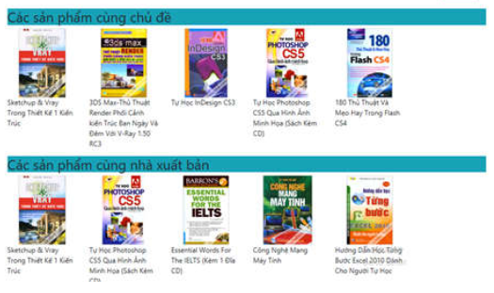

public ActionResult HTSachTheoChuDe(int mcd)

{

List<Sach> dsS = data.Saches.Where(s => s.MaChuDe == mcd).ToList();

return View("Index", dsS);

}

public ActionResult HTSachTheoNXB(int mnxb)

{

List<Sach> dsS = data.Saches.Where(s => s.MaNXB == mnxb).ToList();

return View("Index", dsS);

}

**View của HTSachTheoChuDe và HTSachTheoNXB nằm trong View của Detail**

<div class=" row">

<h2>Các sản phẩm cùng chủ đề</h2>

<div class="row">

@foreach (Sach s in dscd)

{

<div class=" col-md-2">

<a href="@Url.Action("Details", "BT1", new { id = @s.MaSach})"><img src="/Content/HinhAnhSP/@Model.AnhBia" /></a>

<p>@s.TenSach</p>

</div>

}

</div>

</div>

<div class=" row">

<h2>Các sản phẩm cùng nhà xuất bản</h2>

<div class="row">

@foreach (Sach s in dscd)

{

<div class=" col-md-2">

<a href="@Url.Action("Details", "BT1", new { id = @s.MaSach})"><img src="/Content/HinhAnhSP/@Model.AnhBia" /></a>

<p>@s.TenSach</p>

</div>

}

</div>

</div>

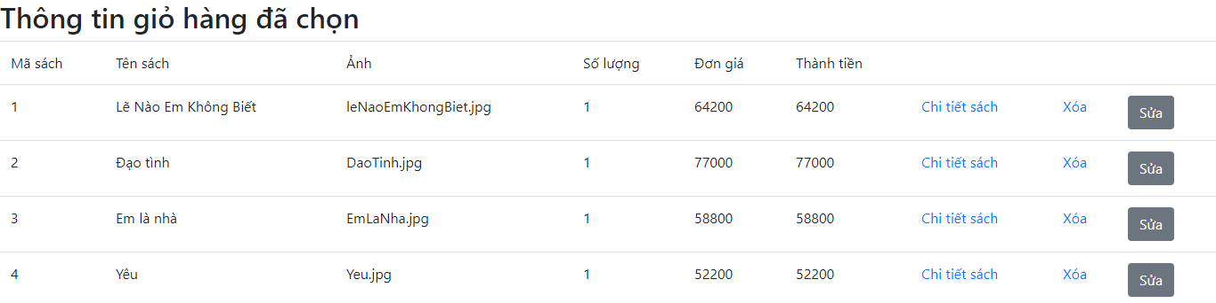

**Tạo Index nằm trong controller QLy**

DataClasses1DataContext data = new DataClasses1DataContext();

public ActionResult Index()

{

List<Sach> dsSach = data.Saches.ToList();

return View(dsSach);

}

**Index dạng List**

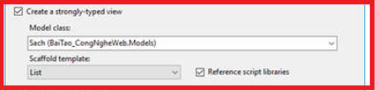

**Goto View Index**

@model IEnumerable<_36_NguyenAnhThu_2001180005_CNWeb7.Models.Sach>

@helper Truncate(string input, int length)

{

if(input.Length < length)

{

@input

}

else

{

@input.Substring(0,length)<text>...</text>

}

}

@{

ViewBag.Title = "Index";

}

<h2>Index</h2>

<p>

@Html.ActionLink("Thêm sách mới", "Create")

</p>

Sửa foreach (nào không cần thiết có thể xóa)

@foreach (var item in Model) {

<tr>

<td>

@Html.DisplayFor(modelItem => item.TenSach)

</td>

<td style="width:100px">

@Html.DisplayFor(modelItem => item.GiaBan)

</td>

<td>

@Truncate(item.MoTa,100)

</td>

<td>

@Html.DisplayFor(modelItem => item.NgayCapNhat)

</td>

<td>

<img style="height:100px; width:150px" src="@Url.Content("~/Content/HinhAnhSP/"+ item.AnhBia)"/>

</td>

<td>

@Html.DisplayFor(modelItem => item.SoLuongTon)

</td>

<td>

@Html.DisplayFor(modelItem => item.ChuDe.TenChuDe)

</td>

<td>

@Html.DisplayFor(modelItem => item.NhaXuatBan.TenNXB)

</td>

<td>

@Html.DisplayFor(modelItem => item.Moi)

</td>

<td>

@Html.ActionLink("Sửa", "SuaSach", new { id=item.MaSach }) |

@Html.ActionLink("Chi tiết", "Chitietsach", new { id=item.MaSach }) |

@Html.ActionLink("Xóa", "XoaSach", new { id=item.MaSach })

</td>

</tr>

}

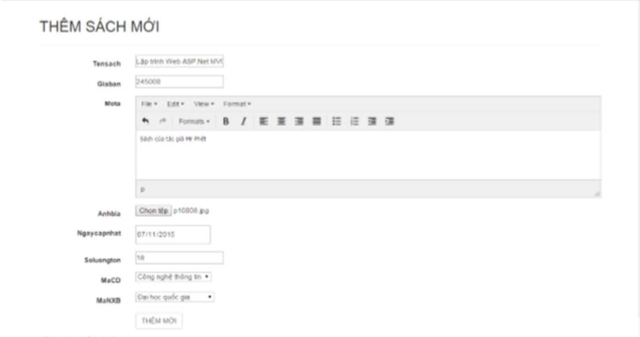

**Thêm sách mới**

[HttpGet]

public ActionResult Create()

{

ViewBag.cd = new SelectList(data.ChuDes.ToList(), "MaChuDe", "TenChuDe");

ViewBag.nxb = new SelectList(data.NhaXuatBans.ToList(), "MaNXB", "TenNXB");

return View();

}

[HttpPost]

[ValidateInput(false)]

public ActionResult Create(Sach s, HttpPostedFileBase fileupload)

{

ViewBag.cd = new SelectList(data.ChuDes.ToList(), "MaChuDe", "TenChuDe");

ViewBag.nxb = new SelectList(data.NhaXuatBans.ToList(), "MaNXB", "TenNXB");

s.MoTa = HttpUtility.HtmlEncode(s.MoTa);

if (fileupload == null)

{

ViewBag.ThongBao = "Vui lòng chọn ảnh bìa";

return View();

}

else

{

if (ModelState.IsValid)

{

var FileName = Path.GetFileName(fileupload.FileName);

var path = Path.Combine(Server.MapPath("~/Content/HinhAnhSP"), FileName);

if (System.IO.File.Exists(path))

ViewBag.ThongBao = "Hình ảnh đã tồn tại";

else

fileupload.SaveAs(path);

s.AnhBia = FileName;

data.Saches.InsertOnSubmit(s);

data.SubmitChanges();

}

return RedirectToAction("Index");

}

}

**Goto View Create (View dạng create)**

@model _36_NguyenAnhThu_2001180005_CNWeb7.Models.Sach

@{

ViewBag.Title = "Create";

}

<script src="~/Content/tinymce/js/tinymce/tinymce.min.js"></script>

<script>

tinymce.init({ selector: "textarea" });

</script>

<h2>Create</h2>

@using (Html.BeginForm("Create", "QLy", FormMethod.Post, new { @enctype = "multipart/form-data"}))

{

@Html.ValidationSummary(true)

<fieldset>

<legend>Sach</legend>

<div class="editor-label">

@Html.LabelFor(model => model.TenSach)

</div>

<div class="editor-field">

@Html.EditorFor(model => model.TenSach)

@Html.ValidationMessageFor(model => model.TenSach)

</div>

<div class="editor-label">

@Html.LabelFor(model => model.GiaBan)

</div>

<div class="editor-field">

@Html.EditorFor(model => model.GiaBan)

@Html.ValidationMessageFor(model => model.GiaBan)

</div>

<div class="editor-label">

@Html.LabelFor(model => model.MoTa)

</div>

<div class="editor-field">

<textarea name="Mota"></textarea>

</div>

<div class="editor-label">

@Html.LabelFor(model => model.NgayCapNhat)

</div>

<div class="editor-field">

<input type="date" name="Ngaycapnhat"/>

</div>

<div class="editor-label">

@Html.LabelFor(model => model.AnhBia)

</div>

<div class="editor-field">

<input type="file" name="fileupload"/>

</div>

<div class="editor-label">

@Html.LabelFor(model => model.SoLuongTon)

</div>

<div class="editor-field">

@Html.EditorFor(model => model.SoLuongTon)

@Html.ValidationMessageFor(model => model.SoLuongTon)

</div>

<div class="editor-label">

@Html.LabelFor(model => model.MaChuDe)

</div>

<div class="editor-field">

@Html.DropDownList("cd")

</div>

<div class="editor-label">

@Html.LabelFor(model => model.MaNXB)

</div>

<div class="editor-field">

@Html.DropDownList("nxb")

</div>

<div class="editor-label">

@Html.LabelFor(model => model.Moi)

</div>

<div class="editor-field">

@Html.EditorFor(model => model.Moi)

@Html.ValidationMessageFor(model => model.Moi)

</div>

<p>

<input type="submit" value="Create" />

</p>

</fieldset>

}

<div>

@Html.ActionLink("Back to List", "Index")

</div>

@section Scripts {

@Scripts.Render("~/bundles/jqueryval")

}



**Chi tiết sách**

public ActionResult Chitietsach(int id)

{

Sach s = data.Saches.SingleOrDefault(n => n.MaSach == id);

ViewBag.MaSach = s.MaSach;

if(s == null)

{

Response.StatusCode = 404;

return null;

}

return View(s);

}

**Goto View Chitietsach (View dạng Detail)**

@model _36_NguyenAnhThu_2001180005_CNWeb7.Models.Sach

@{

ViewBag.Title = "Chitietsach";

}

<h2>THÔNG TIN CHI TIẾT SÁCH</h2>

<fieldset>

<legend>Sach</legend>

<div class="display-label">

@Html.DisplayNameFor(model => model.TenSach)

</div>

<div class="display-field">

@Html.DisplayFor(model => model.TenSach)

</div>

<div class="display-label">

@Html.DisplayNameFor(model => model.GiaBan)

</div>

<div class="display-field">

@String.Format("{0:0,0}", Model.GiaBan) VNĐ

</div>

<div class="display-label">

@Html.DisplayNameFor(model => model.MoTa)

</div>

<div class="display-field">

@Html.DisplayFor(model => model.MoTa)

</div>

<div class="display-label">

@Html.DisplayNameFor(model => model.NgayCapNhat)

</div>

<div class="display-field">

@String.Format("{0:dd/MM/yyyy}", Model.NgayCapNhat)

</div>

<div class="display-label">

@Html.DisplayNameFor(model => model.AnhBia)

</div>

<div class="display-field">

<img style="width:120px" src="@Url.Content("~/Content/HinhAnhSP/" + Model.AnhBia)"/>

</div>

<div class="display-label">

@Html.DisplayNameFor(model => model.SoLuongTon)

</div>

<div class="display-field">

@Html.DisplayFor(model => model.SoLuongTon)

</div>

<div class="display-label">

@Html.DisplayNameFor(model => model.MaChuDe)

</div>

<div class="display-field">

@Html.DisplayFor(model => model.MaChuDe)

</div>

<div class="display-label">

@Html.DisplayNameFor(model => model.MaNXB)

</div>

<div class="display-field">

@Html.DisplayFor(model => model.MaNXB)

</div>

<div class="display-label">

@Html.DisplayNameFor(model => model.Moi)

</div>

<div class="display-field">

@Html.DisplayFor(model => model.Moi)

</div>

</fieldset>

<p>

@Html.ActionLink("Sửa sách", "SuaSach", new { id=Model.MaSach }) |

@Html.ActionLink("Back to List", "Index")

</p>



**Xóa sách**

[HttpGet]

public ActionResult XoaSach(int id)

{

Sach s = data.Saches.SingleOrDefault(n => n.MaSach == id);

ViewBag.MaSach = s.MaSach;

if (s == null)

{

Response.StatusCode = 404;

return null;

}

return View(s);

}

[HttpPost, ActionName("XoaSach")]

public ActionResult Xacnhanxoa(int id)

{

Sach s = data.Saches.SingleOrDefault(n => n.MaSach == id);

ViewBag.MaSach = s.MaSach;

if (s == null)

{

Response.StatusCode = 404;

return null;

}

data.Saches.DeleteOnSubmit(s);

data.SubmitChanges();

return RedirectToAction("Index");

}

**Goto View XoaSach (View dạng Delete)**

@model _36_NguyenAnhThu_2001180005_CNWeb7.Models.Sach

@{

ViewBag.Title = "XoaSach";

}

<h2>XÁC NHẬN THÔNG TIN SÁCH CẦN XÓA</h2>

<h3>Bạn quyết định xóa quyển sách này?</h3>

<fieldset>

<legend>Sach</legend>

<div class="display-label">

@Html.DisplayNameFor(model => model.TenSach)

</div>

<div class="display-field">

@Html.DisplayFor(model => model.TenSach)

</div>

<div class="display-label">

@Html.DisplayNameFor(model => model.GiaBan)

</div>

<div class="display-field">

@Html.DisplayFor(model => model.GiaBan)

</div>

<div class="display-label">

@Html.DisplayNameFor(model => model.MoTa)

</div>

<div class="display-field">

@Html.DisplayFor(model => model.MoTa)

</div>

<div class="display-label">

@Html.DisplayNameFor(model => model.NgayCapNhat)

</div>

<div class="display-field">

@Html.DisplayFor(model => model.NgayCapNhat)

</div>

<div class="display-label">

@Html.DisplayNameFor(model => model.AnhBia)

</div>

<div class="display-field">

@Html.DisplayFor(model => model.AnhBia)

</div>

<div class="display-label">

@Html.DisplayNameFor(model => model.SoLuongTon)

</div>

<div class="display-field">

@Html.DisplayFor(model => model.SoLuongTon)

</div>

<div class="display-label">

@Html.DisplayNameFor(model => model.MaChuDe)

</div>

<div class="display-field">

@Html.DisplayFor(model => model.MaChuDe)

</div>

<div class="display-label">

@Html.DisplayNameFor(model => model.MaNXB)

</div>

<div class="display-field">

@Html.DisplayFor(model => model.MaNXB)

</div>

<div class="display-label">

@Html.DisplayNameFor(model => model.Moi)

</div>

<div class="display-field">

@Html.DisplayFor(model => model.Moi)

</div>

</fieldset>

@using (Html.BeginForm()) {

<p>

<input type="submit" value="Xóa" /> |

@Html.ActionLink("Back to List", "Index")

</p>

}

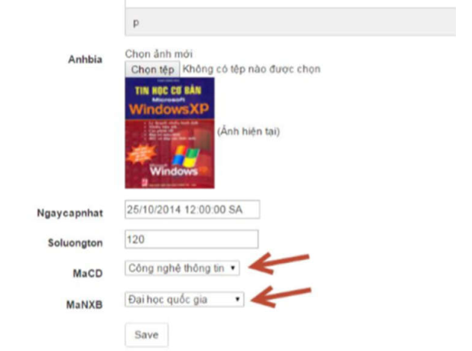

**Sửa sách**

[HttpPost]

[ValidateInput(false)]

public ActionResult SuaSach(Sach s, HttpPostedFileBase fileupload)

{

ViewBag.cd = new SelectList(data.ChuDes.ToList(), "MaChuDe", "TenChuDe");

ViewBag.nxb = new SelectList(data.NhaXuatBans.ToList(), "MaNXB", "TenNXB");

if (fileupload == null)

{

ViewBag.ThongBao = "Vui lòng chọn ảnh bìa";

return View();

}

else

{

if (ModelState.IsValid)

{

var FileName = Path.GetFileName(fileupload.FileName);

var path = Path.Combine(Server.MapPath("~/Content/HinhAnhSP"), FileName);

if (System.IO.File.Exists(path))

ViewBag.ThongBao = "Hình ảnh đã tồn tại";

else

fileupload.SaveAs(path);

s.AnhBia = FileName;

UpdateModel(s);

data.SubmitChanges();

}

return RedirectToAction("Index");

}

}

**Goto View SuaSach (View dạng Edit)**

@model _36_NguyenAnhThu_2001180005_CNWeb7.Models.Sach

@{

ViewBag.Title = "SuaSach";

}

<script src="~/Content/tinymce/js/tinymce/tinymce.min.js"></script>

<script>

tinymce.init({ selector: "textarea" });

</script>

<h2>SuaSach</h2>

@using (Html.BeginForm()) {

@Html.ValidationSummary(true)

<fieldset>

<legend>Sach</legend>

<div style="font:18px; padding: 5px 0 0 5px">@Model.MaSach</div>

<div class="editor-label">

@Html.LabelFor(model => model.TenSach)

</div>

<div class="editor-field">

@Html.EditorFor(model => model.TenSach)

@Html.ValidationMessageFor(model => model.TenSach)

</div>

<div class="editor-label">

@Html.LabelFor(model => model.GiaBan)

</div>

<div class="editor-field">

@Html.EditorFor(model => model.GiaBan)

@Html.ValidationMessageFor(model => model.GiaBan)

</div>

<div class="editor-label">

@Html.LabelFor(model => model.MoTa)

</div>

<div class="editor-field">

<textarea name="Mota">@Model.MoTa</textarea>

</div>

<div class="editor-label">

@Html.LabelFor(model => model.NgayCapNhat)

</div>

<div class="editor-field">

@Html.EditorFor(model => model.NgayCapNhat)

@Html.ValidationMessageFor(model => model.NgayCapNhat)

</div>

<div class="editor-label">

@Html.LabelFor(model => model.AnhBia)

</div>

<div class="editor-field">

<input type="file" name="fileupload"/>

<img style="width:120px" src="@Url.Content("~/Content/HinhAnhSP/" + Model.AnhBia)"/>

</div>

<div class="editor-label">

@Html.LabelFor(model => model.SoLuongTon)

</div>

<div class="editor-field">

@Html.EditorFor(model => model.SoLuongTon)

@Html.ValidationMessageFor(model => model.SoLuongTon)

</div>

<div class="editor-label">

@Html.LabelFor(model => model.MaChuDe)

</div>

<div class="editor-field">

@Html.DropDownList("cd")

</div>

<div class="editor-label">

@Html.LabelFor(model => model.MaNXB)

</div>

<div class="editor-field">

@Html.DropDownList("nxb")

</div>

<div class="editor-label">

@Html.LabelFor(model => model.Moi)

</div>

<div class="editor-field">

@Html.EditorFor(model => model.Moi)

@Html.ValidationMessageFor(model => model.Moi)

</div>

<p>

<input type="submit" value="Save" />

</p>

</fieldset>

}

<div>

@Html.ActionLink("Back to List", "Index")

</div>

@section Scripts {

@Scripts.Render("~/bundles/jqueryval")

}